
FT/PHQP/1221/B 20-SEP-2021
FIRST TERM EXAMINATION (2021-22)
Subject: PHYSICS  Grade: XII |  |  | Max. Marks:35  Time: 90 Minutes
Name: |  |  |  |  |  |  |  |  | Section: |  |  | Roll No:
- General Instructions:
1. The Question Paper contains three sections.
2. Section A has 25 questions. Attempt any 20 questions.
3. Section B has 24 questions. Attempt any20 questions.
4. Section C has 6 questions. Attempt any 5 questions.
5. All questions carry equal marks.
6. There is no negative marking.
SECTION A
This section consists of 25 multiple choice questions with overall choice to attempt any 20 questions. In case more than desirable number of questions are attempted, ONLY first 20 will be considered for evaluation.
 | A hollow metal sphere of radius 5 cm is charged so that the potential on its surface is 10 V. The potential at the centre of the sphere is
 | a. | 0 V |  | b. |  |  | 10 V
 | c. | Same as at point 5 cm away from the surface |  | d. |  |  | Same as at point 25 cm away from the surface
2. | A line charged rod is placed between two insulated conducting spheres as shown. The spheres have no net charge. Region I has the same polarity as Region |  |  |  |  |  |  |  |  | 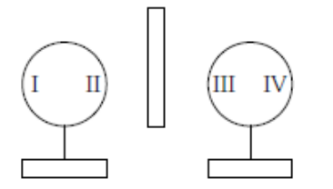
 | a. | III only |  | b. |  |  | IV only
 | c. | II & III only |  | d. |  |  | II & IV only
3. | On moving a charge of 20 coulomb by 2cm, 2J of work is done, then the potential difference between the points is
 | a. | 0.1 V |  | b. |  |  | 8V
 | c. | 2 V |  | d. |  |  | 0.5 V
4. | Three points A, B and C lie in a uniform electric field E of 5x10³ NC⁻¹ as shown in the figure. Find the potential difference between A and C |  |  |  |  |  |  | 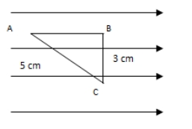
 | a. | 25 V |  | b. |  |  | 20V
 | c. | 15 V |  | d. |  |  | ZERO
5. | An electric dipole of moment is placed in a uniform electric field . Then  (i) the torque on the dipole is 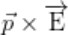  (ii) the potential energy of the system is 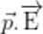  (iii) the resultant force on the dipole is zero. Choose the correct option.
 | a. | (i), (ii) and (iii) are correct |  | b. |  |  | (i) and (iii) are correct and (ii) is wrong
 | c. | only (i) is correct |  | d. |  |  | (i) and (ii) are correct and (iii) is wrong
6. | The Coulomb’s force between two charges q₁ and q₂ separated by distance ‘r’ is F. If the separation between two charges is doubled keeping charges constant, then Coulomb’s force becomes
 | a. | 4F |  | b. |  |  | F/4
 | c. | 2F |  | d. |  |  | F/2
7. | The charge ‘q’ versus potential difference ‘V’ graphs for the series and the parallel combination of two capacitors C₁ and C₂ are shown in the figure. Identify which graph is representing series and which is parallel |  |  |  |  |  |  | 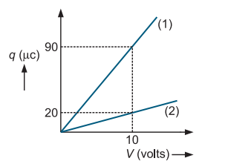
 | a. | 1 is series and 2 is parallel |  | b. |  |  | 1 is parallel and 2 is series
 | c. | Not sufficient information |  | d. |  |  | None of the above
8. | Two wires of same material have length L and 2L and cross–sectional areas 4A and A  respectively. The ratio of their specific resistance would be
 | a. | 1:2 |  | b. |  |  | 1:8
 | c. | 8:1 |  | d. |  |  | 1:1
9. | What is the value of the current Iin the following part of an electrical network?  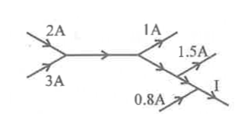
 | a. | 4.7 A |  | b. |  |  | 1.3 A
 | c. | 2.7 A |  | d. |  |  | 3.3 A
10. | A potentiometer is an accurate and versatile device to make electrical measurements of E.M.F, because the method involves :
 | a. | Cells |  | b. |  |  | Potential gradients
 | c. | A condition of no current flow through the galvanometer |  | d. |  |  | A combination of cells, galvanometer and resistances
11 | A piece of copper and silicon are cooled from room temperature to 100 K. The resistance of
 | a. | each of them increases |  | b. |  |  | each of them decreases
 | c. | copper increases and that of silicon decreases |  | d. |  |  | copper decreases and that of silicon increases
12. | Drift velocity v_{d} varies with the intensity of electric field E as per the relation
 | a. |  |  | b.
 | c. |  |  | d. |  |  | ²
13. | The following graph shows the variation of terminal potential difference V, across 2 cells in series to a resistor, versus the current, (I) drawn from the cell. For a cell, the graph between the potential difference (V) across the terminals of the cell and the current (I) drawn from the cell is shown in figure. Find The emf of each cell  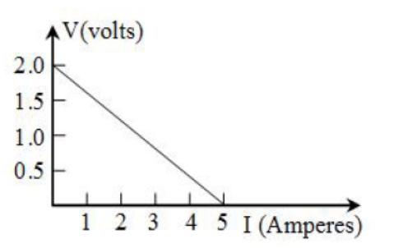
 | a. | 2V |  | b. |  |  | 1V
 | c. | 1.5V |  | d. |  |  | Can’t find
14. | Calculate the current drawn from the battery in the given network  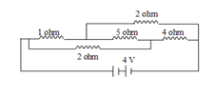
 | a. | 2/3 A |  | b. |  |  | 8/9 A
 | c. | 2 A |  | d. |  |  | 4/3 A
15. | Lines of force, due to earth’s horizontal magnetic field, are
 | a. | elliptical |  | b. |  |  | curved lines
 | c. | concentric circles |  | d. |  |  | parallel and straight
16. | Three long, straight parallel wires, carrying current are arranged as shown in the figure. The force experienced by a 25 cm length of wire C is  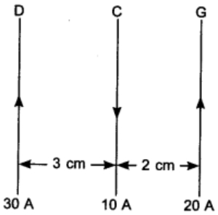
 | a. | 10⁻³ N |  | b. |  |  | 2.5 × 10⁻³ N
 | c. | Zero |  | d. |  |  | 1.5 ×10 ³ N
17. | Current sensitivity of a galvanometer can be increased by decreasing :
 | a. | Magnetic field |  | b. |  |  | Number of turns
 | c. | Torsional constant |  | d. |  |  | Area
18. | Let the magnetic field on earth be modeled by that of a point magnetic dipole at the centre of earth. The angle of dip at a point on the geographical equator
 | a. | is always zero. |  | b. |  |  | can be zero at specific points.
 | c. | cannot be positive or negative |  | d. |  |  | is not bounded
19. | In a certain place, the horizontal component of magnetic field is 1/ √3 times the vertical component. The angle of dip at this place is
 | a. | 0 |  | b. |  |  | π/3
 | c. | π/6 |  | d. |  |  | π/4
20. | The ratio of average induced emf to the rate of change of current in the coil is called
 | a. | Self-inductance |  | b. |  |  | Mutual inductance
 | c. | Self-induction |  | d. |  |  | Mutual induction
21. | In an AC generator, a coil with N turns, all of the same area A and total resistance R, rotates with frequency ω in a magnetic field B. The maximum value of emf generated in the coil is
 | a. | N. A. B |  | b. |  |  | N. A. B. R
 | c. | N. A. B. ω |  | d. |  |  | N. A. B. R.ω
22. | In the given figure current from A to B in the straight wire is decreasing. The direction of induced current in the loop is A |  |  |  | 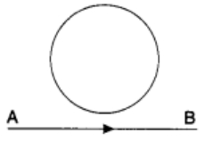
 | a. | clockwise |  | b. |  |  | anticlockwise
 | c. | changing |  | d. |  |  | nothing can be said
23. | The average value of a 12 V peak sine wave over one complete cycle is
 | a. | 7.64 V |  | b. |  |  | 1.27 V
 | c. | 6.37 V |  | d. |  |  | 0 V
24. | The value of L, C and R for a circuit are 1H, 9F and 3Ω. What is the quality factor for the circuit at resonance
 | a. | 1 |  | b. |  |  | 9
 | c. | 1/9 |  | d. |  |  | 1/3
25. | In the circuit shown in figure the r.m.s. value of e is 5 V and r.m.s. value of voltage drop across L is 3V.  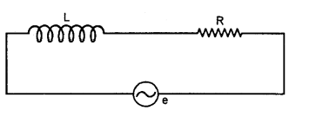  The r.m.s. value of voltage across R will be
 | a. | 2 V |  | b. |  |  | 3 V
 | c. | 4 V |  | d. |  |  | 0 V
SECTION B
This section consists of 24 multiple choice questions with overall choice to attempt any 20 questions. In case more than desirable number of questions are attempted, ONLY first 20 will be considered for evaluation.
26. | A point charge 6q is at a distance of d/2 directly above the centre of a square of side d, as shown in the figure. Use Gauss’ law to obtain the expression for the electric flux through the square. If the point charge is now moved to a distance ‘d’ from the centre of the square and the side of the square is doubled, explain how the electric flux will be affected. |  |  |  |  |  |  |  |  | 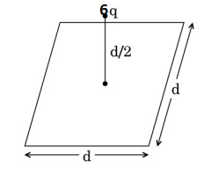
 | a. | q/6Ɛ₀ , 6q/Ɛ₀ |  | b. |  |  | q/Ɛ₀ , q/Ɛ₀
 | c. | 6q/Ɛ₀ , q/6Ɛ₀ |  | d. |  |  | 6q/Ɛ₀ , 6q/Ɛ₀
27. | A capacitor is charged by using a battery which is then disconnected. A dielectric slab is then inserted between the plates, which results in
 | a. | reduction of charge on the plates and increase of potential across the plates |  | b. |  |  | increases in the potential difference across the plates, reduction in stored energy, but no change in the charge on the plates
 | c. | decrease in the potential difference across the plates, reduction in stored energy, but no change in the charge on the plates |  | d. |  |  | none of the above
28. | In the given figure if E represents the direction of the increasing electric field then find the direction of force experienced by the given dipole is  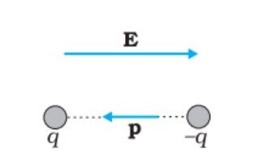
 | a. | Left |  | b. |  |  | Right
 | c. | No force |  | d. |  |  | Only torque will be experienced
29. | Two infinitely large plane thin parallel sheets having surface charge densities σ1 and σ2 , (σ 1 > σ 2 ) are shown in the figure. Write the magnitudes and directions of the net fields in the regions marked II and III. |  |  |  |  |  |  | 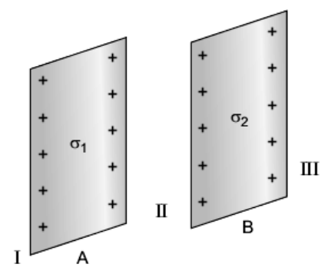
 | a. | 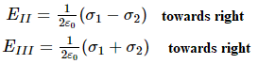 |  | b. |  |  | 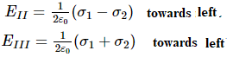
 | c. | 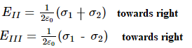 |  | d. |  |  | 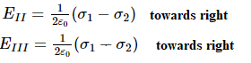
30. | A small conducting sphere of radius r is lying concentrically inside a bigger hollow conducting sphere of radius R. The bigger and smaller spheres are charged with Q and q(Q > q) and are insulated from each other. The potential difference between the spheres will be:
 | a. | 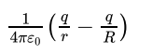 |  | b. |  |  | 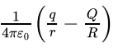
 | c. | 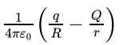 |  | d. |  |  | 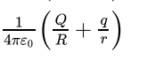
31. | In a transformer, number of turns in the primary are 140 and that in the secondary are 280. If current in primary is 4A, then that in the secondary is
 | a. | 4A |  | b. |  |  | 2A
 | c. | 6A |  | d. |  |  | 10 A
32. | An inductor of reactance 1 Ω and a resistor of 2 Ω are connected in series to the terminals of a 6 V (rms) a.c. source. The power dissipated in the circuit is
 | a. | 8 W. |  | b. |  |  | 12 W.
 | c. | 14.4 W |  | d. |  |  | 18 W
33. | Two metal plates form a parallel plate capacitor. The distance between the plates is d. A metal sheet of thickness and of the same area is introduced between the plates. What is the ratio of the capacitance in the two cases?
 | a. | 2 : 1 |  | b. |  |  | 3 : 1
 | c. | 1 : 1 |  | d. |  |  | 5 : 1
34. | Find out the value of current through 2 ohm resistance for the given circuit  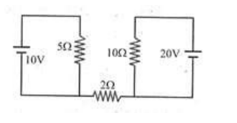
 | a. | 4A |  | b. |  |  | 5 A
 | c. | 2 A |  | d. |  |  | Zero
35. | 4 cells, each of emf 2 V and internal resistance of 1 ohm are connected in parallel to a load resistor of 2 ohm. Then, the current through the load resistor is:
 | a. | 0.888 A |  | b. |  |  | 2 A
 | c. | 1.5 A |  | d. |  |  | 1 A
36. | The voltage V and current I graph for a conductor at two different temperatures T1 and T2 are shown in the figure. The relation between T1 and T2 is  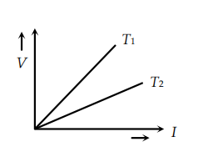
 | a. | 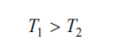 |  | b. |  |  | 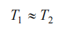
 | c. | 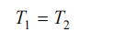 |  | d. |  |  | 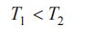
37. | Two cells of e.m.f. E₁ and E₂ (E₁>E₂) are connected as shown in the figure. When a potentiometer is connected between A and B, the balancing length of the potentiometer wire is 300 cm. On connecting the same potentiometer between A and C, the balancing length is 100 cm. Calculate the ratio of E1 and E2. |  |  |  |  |  |  | 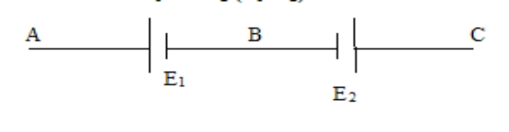
 | a. | 4:1 |  | b. |  |  | 3:2
 | c. | 2:3 |  | d. |  |  | 2:1
38. | An alpha-particle and a proton moving with the same speed enter the same magnetic field region at right angles to the direction of the field. Show the trajectories followed by the two particles in the region of the magnetic field. Find the ratio of the radii of the circular paths which the two particles may describe.? |  |  |  |  |  |  |  |  |  | 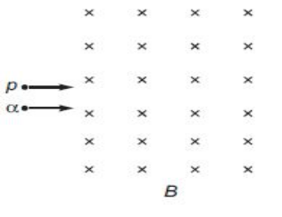
 | a. | 2:1 |  | b. |  |  | 1:2
 | c. | 4:1 |  | d. |  |  | 1:4
39. | The magnetic induction at the centre O of the current loop shown in the adjoining diagram is  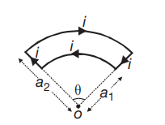
 | a. | 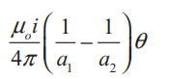 |  | b. |  |  | 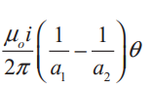
 | c. | 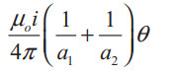 |  | d. |  |  | 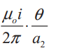
40. | What is the torque and froce I the two cases as shown in the figure ?  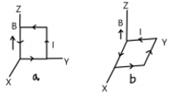
 | a. | , Fa 0, F_{b} 0 |  | b. |  |  | 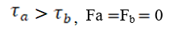
 | c. | , Fa F_{b} 0 |  | d. |  |  | , Fa F_{b} 0
41. | A metallic cylinder is held vertically and then or small magnet is dropped along its axis. It will fall with
 | a. | acceleration a>g |  | b. |  |  | acceleration a<g
 | c. | acceleration a=g |  | d. |  |  | constant velocity a=0
42. | The current I in an inductance coil is varying with time t as shown in the figure. Which one of the following graphs shows the variation of voltage in the coil with time?  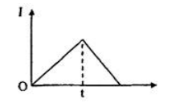
 | a. | 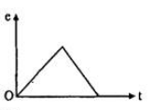 |  | b. |  |  | 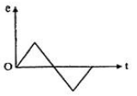
 | c. | 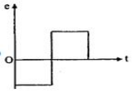 |  | d. |  |  | 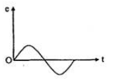
43. | Figure shows a rectangular conducting loop PQSR in which arm RS of length ‘l’ is movable. The loop is kept in a uniform magnetic field ‘B’ directed downward perpendicular to the plane of the loop. The arm RS is moved with a uniform speed ‘v’ the external force required to move the arm |  |  |  |  | 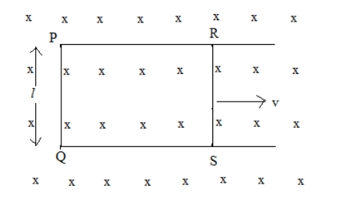
 | a. | -B²l²v/R |  | b. |  |  | -B²l²v²/ R
 | c. | +B²l²v/R |  | d. |  |  | Blv
44. | A solenoid of length 30cm with 10 turns per centimetre and area of cross-section 40 cm² completely surrounds another co-axial solenoid of same length, area of cross-section 20 cm² with 40 turns per centimeter. The mutual inductance of the system is:
 | a. | 3 Mh |  | b. |  |  | 0.301 mH
 | c. | 10 H |  | d. |  |  | 8 H
For question numbers 45-49 two statements are given- one labeled Assertion (A) and the other labeled Reason (R).
Select the correct answer to these questions from the codes (a), (b), (c) and (d) as given below:
a) Both A and R are true, and R is correct explanation of the assertion.
b) Both A and R are true, but R is not the correct explanation of the assertion.
c) A is true, but R is false.
d) A is false, but R is true.
45. | Assertion (A): A charged particle is moving in a circular path under the action of a uniform  magnetic field. During the motion, kinetic energy of the charged particle is constant.  Reason (R): During the motion, magnetic force acting on the particle is perpendicular to  instantaneous velocity.
46. | Assertion(A) : When charges are shared between two bodies, there occurs no loss of charge but there does occur a loss of energy.  Reason(R ): In case of sharing of charges, conservation of energy fails
47. | Assertion (A): The angle of dip is maximum at the poles of the earth.  Reason (R): The magnetic field lines are parallel to the surface of the earth at the poles.
48. | Assertion (A): A phosphor bronze strip is used in a moving coil galvanometer.  Reason (R): Phosphor bronze strip has the maximum value of torsional constant k
49. | Assertion (A): The magnetic field at the ends of a very long current carrying solenoid is half of that at the centre.  Reason (R): If the solenoid is sufficiently long, the field within it is uniform
SECTION C
This section consists of 6 multiple choice questions with an overall choice to attempt any 5. In case more than desirable number of questions are attempted, ONLY first 5 will be considered for evaluation.
50. | Four charges are arranged at the comers of a square ABCD, as shown. The force on the charge kept at the centre O is  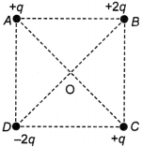
 | a. | zero |  | b. |  |  | along the diagonal AC
 | c. | along the diagonal BD |  | d. |  |  | perpendicular to side AB
51. | The ratio of energy stored by the series combination of two identical capacitors to their parallel combination , when connected to same supply voltage, is
 | a. | 1 |  | b. |  |  | 1/2
 | c. | 4 |  | d. |  |  | 1/4
Case study : Read the following paragraph and answers the questions:
Series LCR AC Circuit
When a pure resistance R, pure inductor L and an ideal capacitor of capacitance C is connected in series to a source of alternating e.m.f., then current at any instant through the three elements has the same amplitude and is represented as I = I_{o}sinωt. However, voltage across each element has a different phase relationship with the current as shown in graph.
The effective resistance of RLC circuit is called impedance (2) of the circuit and the voltage leads the current by a phase angle ϕ.
52. | The graph shows the variation of R, XL and XC with frequency R, XL , XC for a series LCR circuit. Resonance occurs for |  |  |  | 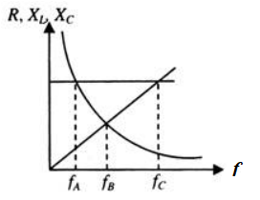
 | a. | f = f_{A} |  | b. |  |  | f = f_{B}
 | c. | f = f_{C} |  | d. |  |  | f_{B} ≤ f ≤ f_{C}
53. | In a R-L-C circuit
 | a. | Power is consumed in resistance and is equal to IR |  | b. |  |  | Exchange of power takes place between inductor and supply line
 | c. | Exchange of power takes place between capacitor and supply line |  | d. |  |  | All above are correct
54. | In the circuit shown in figure, what will be the reading of the voltmeter ? |  |  |  | 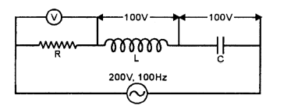
 | a. | 300 V |  | b. |  |  | 900 V
 | c. | 200 V |  | d. |  |  | 400 V
55. | In a series LCR circuit, resistance R = 10Ω and the impedance Z = 20Ω. The phase difference between the current and the voltage is
 | a. | 30 degree |  | b. |  |  | 45 degree
 | c. | 60 degree |  | d. |  |  | 90 degree

***

